Elijah Andrushenko

CPTS 453

Graph Theory

11-27-2019

Homework 5

1.

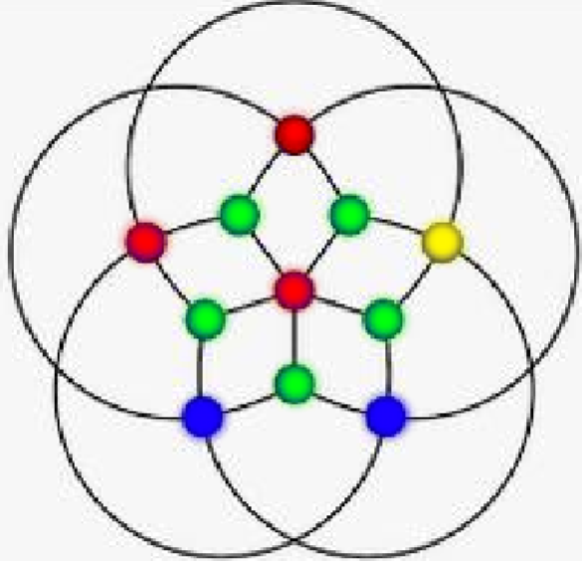

Here is a visual representation.

The important part here is to see that the yellow vertex can’t be green, blue, or red since it is adjacent to all of those colors. Every variant of proper colorings of this graph will lead us to seeing that one of the vertices with 4 edges will have at least 3 unique colors adjacent to it. This has to do with the fact that the 4 vertices adjacent to the yellow vertex will always end up having to have 3 unique colors otherwise there will be improper colorings if we only use 2 colors to color the 4 vertices adjacent to the yellow vertex. We need at least 3 leading us the yellow vertex situation where the graph now have 4 colors meaning X(G) = 4.

2.

**Case 1: Poles are colored the same**

If the two end vertices are colored the same then there are $k$ ways to color the polar vertices. Each of the middle vertices can be colored in $\left(k-1\right)$ ways. Leaving us with

$$k \left(k-1\right)\left(k-1\right)\left(k-1\right)\left(k-1\right)=k{(k-1)}^{4}$$

**Case 2: Poles are colored differently**

If the two end vertices are colored differently then there are $k$ ways to color one polar vertex and there are $(k-1)$ ways to color the other polar vertex. Then each of the middle vertices can be colored in $\left(k-2\right)$ ways. Leaving us with

$$k\left(k-1\right)\left(k-2\right)\left(k-2\right)\left(k-2\right)\left(k-2\right)=k(k-1){(k-2)}^{4}$$

**Result**

Therefore the number of ways to color $K_{4,2}$ is $k{(k-1)}^{4}+k(k-1){(k-2)}^{4}$

3.

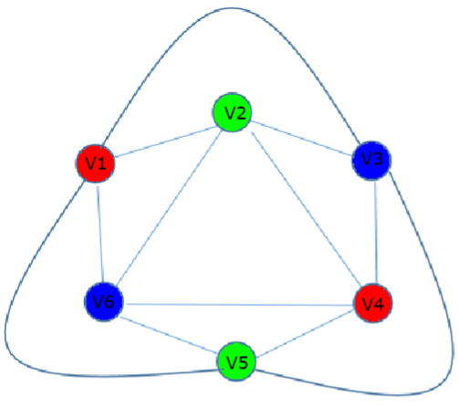

X(G) = 3

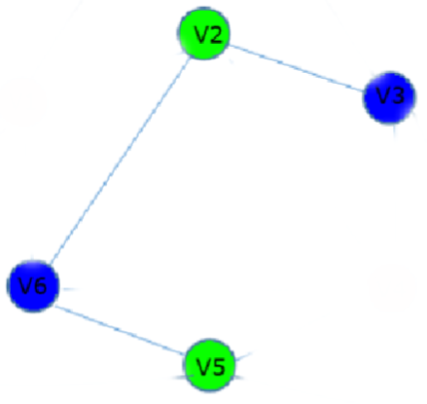

This is the Critical Subgraph

4.

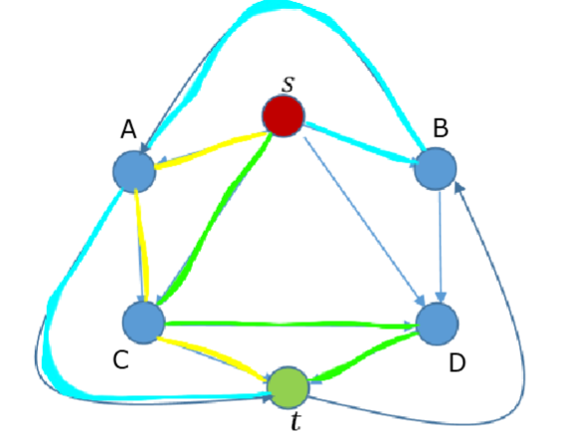

Yellow Path + Teal Path + Green Path = 1 + 1 + 1 = 3

The Maximum Flow is 3.

The minimum cut ̃ = {{A, t}, {C, t}, {D, t}}

5.

|  |  |  |
| --- | --- | --- |
| **Team** | **Wins** | **Losses** |
| 1 | 2 | 2 |
| 2 | 1 | 3 |
| 3 | 3 | 1 |
| 4 | 1 | 3 |
| 5 | 3 | 1 |

**Tie Breakers**

Team 3 and 5 are tied but from the graph we see that team 3 beat team 5 directly so the tie breaker belongs to team 3. Team 2 and 4 are also tied but from the graph we see that team 2 beat team 4 directly so the tie breaker belong to team 2.

**Rankings**

1. Team 3

2. Team 5

3. Team 1

4. Team 2

5. Team 4